Advanced Training

in Open and Endoscopic Surgery: A Hands-on

Skull Base Training Program in Chicago

Comprehensive dissection experience that includes three lab days

March 7-9, 2025

Downtown Chicago on the campus of Northwestern Memorial Hospital

Course directors

James P. Chandler, MD, and Robert C. Kern, MD

Bringing together skill sets from neurosurgery and otolaryngology, this comprehensive three-day course offers a unique opportunity to collaborate and learn complex surgical techniques from some of the top experts in the field of skull base pathologies, and to take advantage of the leading-edge technologies and cadaver dissection available in our lab.

The Skull Base Lab team instructs via didactic presentation, 3D and virtual reality (VR) anatomy demonstration, and guided cadaveric dissection. Participating surgeons get hands-on dissection experience using specimens to practice several complex approaches in both open and endoscopic cranial base surgery.

On completion of the course, participants will be able to:

Review the surgical approaches (open and endoscopic) for complex skull base pathologies.

Recognize the advantages of a team-based approach for managing pre-, peri- and postoperative skull base pathologies.

Demonstrate proficient endoscopic instrument handling and perform standard open skull base approaches.

Master minimally invasive endoscopic endonasal approaches to the sellar and peri-sellar area through advanced orbital-zygomatic craniotomy.

Identify complex skull base pathologies.

View the agenda and register online:

##### [nmskullbase.org/advanced-training](http://nmskullbase.org/advanced-training)

Northwestern Memorial Hospital

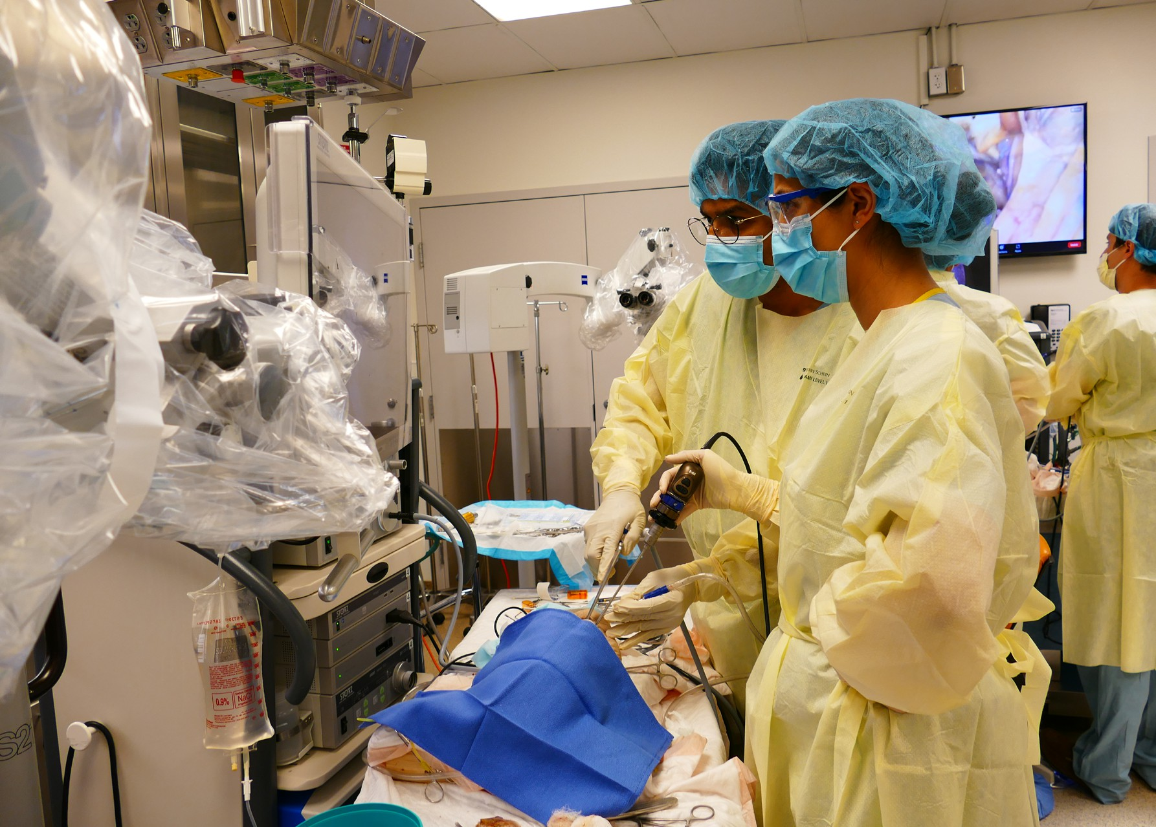

nm.org

Continued >

# Course Details

Location and parking

Northwestern Simulation Laboratory

McGaw Pavilion

240 East Huron Street, Suite LC-0540 Chicago, Illinois 60611

Discounted day and overnight parking will be available at 222 East Huron Street.

Audience

This comprehensive three-day course is designed for both novice and experienced surgeons, residents and fellows in neurosurgery and otolaryngology.

Registration fees

* Attending physician $2,500
* Trainee $1,000
* Pair registration (neurosurgery and otolaryngology – head and neck surgery) $3,500
* Northwestern University Feinberg School

of Medicine alumni $1,000

Breakfast, refreshments, lunch, and Friday dinner are provided. Space is limited.

Hotel accommodations

We have a limited number of rooms reserved for participants coming from out of town.

[Please call Rajashree Sarkar](mailto:laura.jaros@nm.org) at 312-695-2523 or email [**rajashree.sarkar@northwestern.edu**](mailto:rajashree.sarkar@northwestern.edu)for information.

Accreditation statement

The Northwestern University Feinberg School of Medicine is accredited by the Accreditation Council for Continuing Medical Education (ACCME) to provide continuing medical education for physicians

Credit Designation Statement

The Northwestern University Feinberg School of Medicine designates this live activity for a *maximum of 21.75 AMA PRA Category 1 Credit(s)™*. Physicians should claim only the credit commensurate with the extent of their participation in the activity.

American Board of Surgery Accredited CME

Successful completion of this CME activity enables the learner to earn credit toward the CME requirements of the American Board of Surgery’s Continuous Certification program. It is the CME activity provider's responsibility to submit learner completion information to ACCME for the purpose of granting ABS credit “Questions? ABS CME credits will be submitted to the board within 3 months of the conclusion of the activity.

### Email: [rajashree.sarkar@northwestern.edu](mailto:rajashree.sarkar@northwestern.edu)

Phone: **312-695-2523**

Registration

To register, please visit [**nmskullbase.org/advanced-training.**](http://nmskullbase.org/advanced-training)You can also contact Rajashree Sarkar at 312-695-2523 or

### [rajashree.sarkar@northwestern.edu.](mailto:rajashree.sarkar@northwestern.edu)

Sponsored by

Northwestern Skull Base Laboratory

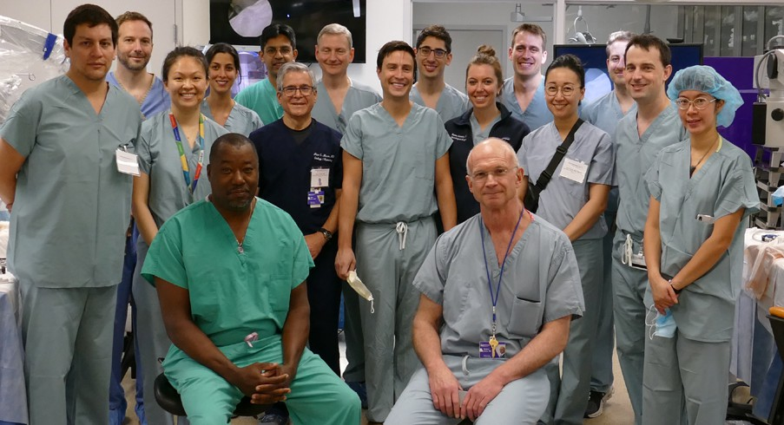

Course Faculty

Course directors James P. Chandler, Robert C. Kern, MD

Northwestern faculty

Stephen Magill MD, PhD

Osaama Khan MD

Michael Walsh MD

Kevin Zhan MD

David Conley MD

Richard M. Wiet MD

Alexander Schneider MD

Guest speakers

Omar Arnaout, MD

Jean Anderson Eloy, MD, FACS, FARS

Timothy R. Smith, MD, PhD

Gabriel Zada MD

Event details are subject to change based on community spread of COVID-19. We will follow Northwestern Medicine safety guidelines at the time of the event.

Continued >

# Course Agenda

## Friday, March 7

7:00 am Registration, 3-D Device Set Up

7:15 am Welcome/Course Overview

#### James P Chandler, MD

7:30 am 3D Anatomy

#### Michael Walsh, MD

8:00 am Extended endoscopic endonasal

Dr. Gabriel Zada

8:30 am LAB: Endoscopic Dissection

10:00 am Endoscopic Anterior Cranial

## Saturday, March 8

7:00 am Breakfast, 3D Device Set Up

7:30 am 3D Anatomy

*Michael Walsh, MD*

### 8:00 am Transcranial Suprasellar - orbitozygomatic approach

#### Osaama Khan, MD

8:30 am LAB: Open Dissection

10:00 am **Lateral Subtemporal Approach to the Middle Cranial Fossa with anterior petrosectomy** *Kevin Zhan, MD, and Timothy R. Smith, MD, PhD*

Base Resection: Suprasellar

Approach

Dr. Jean Anderson Eloy

Noon

Lunch

10:30 am ***Reconstruction of skull base***

#### David B. Conley, MD

11:00 am LAB: Endoscopic Dissection Noon Lunch

1:00 pm 3D Anatomy

Michael Walsh, MD

1:30pm Endoscopic Endonasal Transpterygoid/ Transmaxillary Approach to the Middle Cranial Fossa

#### Jean Anderson Eloy, MD, FACS, FARS, and Robert C. Kern, MD

2:00 pm LAB: Endoscopic Dissection

3:30 pm Endoscopic Endonasal Transclival Approach

#### Stephen T. Magill, MD, PhD

4:00 pm LAB: Endoscopic Dissection 5:30 pm Review and Adjournment

7:00 pm Dinner With Faculty and Participants

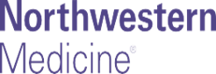1:00 pm 3D Anatomy

*Michael Walsh, MD*

### 1:30 pm Far lateral Transcondylar approach

#### James P Chandler, MD

2:00 pm LAB: Open Dissection

### 3:30 pm Trans petrosal Approach to the Clivus and petrous apex

#### Omar Arnaout, MD

4:00 pm LAB: Open Dissection 5:30 pm Review and Adjournment

## Sunday, March 9

8:00 am Breakfast

9:00 am Complication Avoidance and Management

Gabriel Zada, MD

*James P Chandler, MD Robert Kern, MD Osaama Khan, MD Stephen Magill MD, PhD David Conley, MD*

10:00 am LAB: Open Dissection

12.00 to 1pm Endoscopic Transorbital approach

*Osaama khan, MD*

*Stephen Magill, MD PhD*