RIC’s Dept of Orthopedic Surgery presents:
“Plight of Ananapopolous”
Miss Piggy, MD, PhD & Kermit Frog, RN
Northwestern University Feinberg School of Medicine

Date: November 15, 2016
Time: 12:00pm – 1:00pm
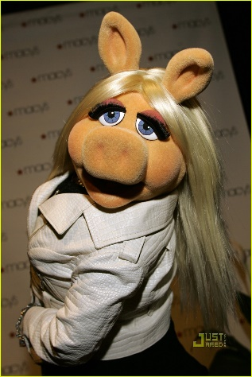
Location: McGaw 1-210

Objectives:
At the conclusion of this activity, participants should be able to:
- Define the management of Anaanapopulous
- Describe the prognosis of Anaanapopulous

Miss Piggy, MD, PhD & Kermit Frog, RN have nothing to disclose. The Course Director, Foz E. Bear, MD has nothing to disclose.
FSM’s CME Leadership and Staff have nothing to disclose:
Clara J. Schroedl, MD, Medical Director of CME, Sheryl Corey, Manager of CME, Jennifer Banys, Senior Program Administrator, Allison McCollum, Senior Program Coordinator, and Rhea Alexis Banks, Administrative Assistant 2.

Accreditation Statement
The Northwestern University Feinberg School of Medicine is accredited by the Accreditation Council for Continuing Medical Education (ACCME) to provide continuing medical education for physicians.

Credit Designation Statement
The Northwestern University Feinberg School of Medicine designates this live activity for a maximum of 1.0 AMA PRA Category 1 Credit(s)™. Physicians should claim only the credit commensurate with the extent of their participation in the activity.

This activity is supported by an educational grant from Puppeteer Medical Device Company, Inc.

Grand Rounds
Dept of the Alliance

Speaker: Dr. Han Solo
Northwestern University Feinberg School of Medicine
Date: November 18, 2016
Time: 12:00pm – 1:00pm
Location: McGaw 1-210
Topic: The Art of Negotiation
Objective: Discuss the technique of shooting first
Dr. Han Solo receives funding from Jabba Hut Inc. and CC, LLC.

Speaker: Dr. Princess Leia
Northwestern University Feinberg School of Medicine
Date: November 25, 2016
Time: 12:00pm – 1:00pm
Location: McGaw 1-210
Topic: How to lead an Alliance to restore the Republic
Objectives: 1. Identify key stake holders in your volunteer base.
2. Describe the use of droids and nerf herders as resources.
Dr. Princess Leia has nothing to disclose.

Course Director: Dr. Yoda
Northwestern University Feinberg School of Medicine
Dr. Yoda has nothing to disclose.

FSM’s CME Leadership and Staff have nothing to disclose:
Clara J. Schroedl, MD, Medical Director of CME, Sheryl Corey, Manager of CME, Jennifer Banys, Senior Program Administrator, Allison McCollum, Senior Program Coordinator, and Rhea Alexis Banks, Administrative Assistant 2.

Accreditation Statement
The Northwestern University Feinberg School of Medicine is accredited by the Accreditation Council for Continuing Medical Education (ACCME) to provide continuing medical education for physicians.

Credit Designation Statement
The Northwestern University Feinberg School of Medicine designates this live activity for a maximum of 1.0 AMA PRA Category 1 Credit™. Physicians should claim only the credit commensurate with the extent of their participation in the activity

